**Data Analytics Project**

**HR Analytics of Innovare Labs**

**Overview**

Developed a comprehensive HR Analytics framework to analyze and optimize workforce metrics, enabling data-driven decision-making for enhanced organizational performance.

**Project Objectives**

* Streamline HR data analysis and reporting processes.
* Provide actionable insights into workforce trends, including attrition, hiring, and performance metrics.
* Suggest solutions for top management to reduce employee attrition.

**Tools & Techniques Used: -**

Power BI  
Power Query  
DAX  
Calculated Measures  
Calculated Columns  
Snowflake Schema  
Page Navigator

**Created By – SHASHANK SINGH**

**Theory and Background: HR Analytics at Innovare Labs**

**Introduction to HR Analytics**  
Human Resource (HR) Analytics is the strategic application of data analysis techniques and tools to human resource management. It involves collecting, analyzing, and interpreting workforce data to optimize employee performance and align HR strategies with organizational objectives. As businesses operate in increasingly complex environments, leveraging HR Analytics allows organizations to gain actionable insights into workforce dynamics and create evidence-based solutions to pressing HR challenges.

This project focuses on applying HR Analytics at **Innovare Labs**, a fictional, medium-sized technology company specializing in software development and digital solutions. With a workforce of 500 employees spread across diverse teams, Innovare Labs is a data-driven organization that values innovation, collaboration, and excellence. However, like many companies, Innovare Labs faces challenges in areas such as employee retention, recruitment efficiency, and performance optimization. This project seeks to analyze workforce trends and provide actionable insights for improving HR outcomes.

**HR Challenges at Innovare Labs**  
Innovare Labs operates in a competitive technology sector where talent is a key driver of success. Some of the primary HR challenges faced by the company include:

1. **Employee Retention**: High turnover rates, particularly in critical roles, impact project delivery and increase recruitment costs.
2. **Talent Acquisition**: With an increasing demand for niche technical skills, the company faces extended time-to-hire and high cost-per-hire metrics.
3. **Employee Engagement**: Ensuring employees feel motivated and connected, especially in a hybrid work environment, remains a priority.
4. **Performance Management**: Identifying high-potential employees and aligning their development with organizational goals is a constant challenge.
5. **Diversity and Inclusion**: The company aims to foster a more inclusive culture but needs data-driven insights to evaluate and improve its initiatives.

**Why Reducing Employee Attrition is Important for a Company: -**

Reducing employee attrition is critical for a company’s success and sustainability. High attrition rates can lead to significant challenges and costs that impact organizational performance, culture, and bottom-line profitability. Here are the key reasons why reducing employee attrition is important:

**1. Financial Savings**

* **Cost of Recruitment**: High turnover increases recruitment costs, including advertising, hiring fees, and onboarding expenses.
* **Training and Development**: New hires require training, which consumes resources and takes time before they reach full productivity.
* **Lost Productivity**: Departing employees leave behind a gap in knowledge and skills that can reduce team efficiency and project timelines.

**2. Retaining Institutional Knowledge**

Experienced employees carry institutional knowledge, including industry insights, client relationships, and internal processes. Frequent attrition can result in a loss of critical expertise, which can be difficult and time-consuming to replace.

**3. Maintaining Employee Morale**

High turnover can create instability and negatively impact the morale of remaining employees. It can lead to:

* Increased workloads for existing staff.
* A perception of organizational instability.
* Decreased trust and engagement among employees.

**4. Enhancing Customer Satisfaction**

Attrition in client-facing roles can disrupt relationships and affect service quality. Retaining skilled employees ensures continuity, strengthens client trust, and maintains customer satisfaction.

**5. Supporting Organizational Culture**

Frequent employee exits can weaken company culture and reduce cohesion within teams. A stable workforce helps build a positive work environment and fosters stronger collaboration.

**6. Reducing Leadership Challenges**

Attrition of key personnel, especially in leadership or critical roles, can disrupt strategic initiatives and create gaps in decision-making. Retaining top talent ensures the organization stays aligned with its long-term goals.

**7. Improving Employer Brand**

High turnover rates can harm a company’s reputation, making it less attractive to potential employees. A strong retention record enhances the employer brand, attracting skilled candidates and reducing recruitment efforts.

**8. Enabling Long-term Growth**

Organizations that retain employees can invest in their growth and development over time, fostering leadership from within. This continuity supports innovation, strengthens succession planning, and contributes to long-term growth.

**Conclusion**

Reducing employee attrition is essential for maintaining operational stability, fostering a positive work environment, and ensuring the efficient use of resources. By addressing the root causes of attrition, such as poor engagement, lack of career advancement, or misalignment with organizational culture, companies can retain talent and drive sustained success.

**Why Employee Ratings matter for an organization: -**

Employee ratings on aspects such as work environment, work-life balance, and job satisfaction are crucial for a company for several reasons. These ratings provide valuable insights into the health of an organization and directly impact its ability to attract, retain, and engage employees.

**1. Gauging Employee Engagement**

* **Insight into Motivation**: High ratings in areas like job satisfaction and work environment indicate motivated and engaged employees who are more productive and committed to the organization.
* **Early Warning Signs**: Declining ratings may signal disengagement or dissatisfaction, allowing the company to address issues before they escalate.

**2. Enhancing Retention**

* **Understanding Turnover Risks**: Ratings related to work-life balance and job satisfaction help identify factors contributing to employee turnover.
* **Retention Strategies**: Feedback allows the company to implement targeted initiatives to improve the workplace and retain top talent.

**3. Attracting New Talent**

* **Employer Branding**: Positive employee ratings improve the company’s reputation, making it more appealing to prospective employees.
* **Competitive Advantage**: In industries with high competition for skilled labor, strong ratings in areas like work-life balance can differentiate the company.

**4. Driving Organizational Performance**

* **Productivity Link**: Employees who rate their work environment and job satisfaction highly are typically more productive and deliver better results.
* **Collaboration and Innovation**: A positive work environment fosters collaboration, creativity, and innovation.

**5. Identifying Improvement Areas**

* **Actionable Insights**: Ratings provide measurable feedback, highlighting specific areas where the company needs to improve, such as communication, leadership, or work-life balance.
* **Employee-Centric Policies**: Feedback can guide policy changes, such as introducing flexible work schedules or enhancing wellness programs.

**6. Supporting Diversity and Inclusion**

* **Monitoring Inclusion Efforts**: Ratings on the work environment can reflect whether employees feel valued and included, helping to track progress on diversity initiatives.
* **Reducing Bias**: Identifying disparities in satisfaction ratings among different employee groups can guide efforts to create a fairer workplace.

**7. Building a Feedback Culture**

* **Two-Way Communication**: Encouraging employees to rate their experiences fosters a culture of open communication and trust.
* **Continuous Improvement**: Regularly collecting and acting on ratings demonstrates the company’s commitment to employee well-being and growth.

**8. Meeting Strategic Goals**

* **Alignment with Mission**: High job satisfaction and work-life balance ratings indicate alignment between employee values and company goals.
* **Sustainability**: A healthy work environment is essential for long-term organizational success and resilience.

**Conclusion**

Employee ratings on the company’s work environment, work-life balance, and job satisfaction serve as a barometer for organizational health. Companies that actively listen to and address this feedback are better equipped to create a positive, productive workplace, attract top talent, and sustain long-term growth.

**The Role of HR Analytics**  
HR Analytics offers a structured approach to address these challenges by using data-driven methodologies. This involves the collection, visualization, and interpretation of HR data to:

* Identify key drivers of employee turnover and propose retention strategies.
* Evaluate recruitment processes to optimize sourcing channels and reduce hiring time.
* Analyze employee engagement survey results and propose actionable interventions.
* Measure performance trends and forecast workforce needs for better planning.
* Assess the effectiveness of diversity and inclusion programs.

**Project Objectives**  
This project aims to implement HR Analytics at Innovare Labs to achieve the following objectives:

1. **Turnover Analysis**: Identify patterns and predictors of employee attrition and develop a retention model.
2. **Recruitment Metrics**: Evaluate time-to-hire, cost-per-hire, and sourcing effectiveness to enhance recruitment efficiency.
3. **Engagement Insights**: Measure employee engagement levels and identify factors influencing satisfaction and productivity.
4. **Performance Forecasting**: Develop a predictive model to identify high performers and potential leadership candidates.
5. **Diversity Metrics**: Analyze representation and inclusion metrics to support the company’s diversity goals.

**Methodological Approach**  
The project leverages a data-driven framework to address these objectives. The approach involves:

1. **Data Collection**: Gathering data from Innovare Labs’ HR Information System (HRIS), employee surveys, performance records, and recruitment databases.
2. **Data Cleaning and Preparation**: Ensuring data quality by handling missing values, outliers, and inconsistencies.
3. **Exploratory Data Analysis (EDA)**: Uncovering patterns and trends using statistical techniques and data visualization tools like Power BI and Tableau.
4. **Predictive Modeling**: Building machine learning models, such as logistic regression for attrition prediction and clustering for employee segmentation.
5. **Visualization and Reporting**: Presenting findings through interactive dashboards to facilitate data-driven decision-making.

**Expected Outcomes**  
Through this project, Innovare Labs will gain actionable insights to:

* Reduce employee turnover by implementing targeted retention strategies.
* Streamline recruitment processes and achieve cost savings.
* Enhance employee engagement and productivity through tailored programs.
* Identify and develop top talent for critical roles.
* Advance the company’s diversity and inclusion objectives.

By integrating HR Analytics into its decision-making processes, Innovare Labs can transform its workforce management strategies, fostering a more engaged and high-performing organization. This project not only addresses current HR challenges but also establishes a scalable framework for ongoing workforce optimization.

**Analysis & Findings: -**

The first step in our analysis to import data which we have received in csv files and build a data model in Power BI.

We have received 5 csv files:- EducationLevel.csv, Employee.csv, PerformanceRating.csv, RatingLevel.csv and SatisfiedLevel.csv  
I have created table in our model and added “Fact” or “Dim” at the beginning of each table name, depending on the type of table it is. Then I have checked each column of all tables in power query for any error and correctly formatted data type as text, whole numbers, decimal numbers and date based on type of data I found in those columns.

In the Performance rating table the column review date was not formatted as date and because it was formatted as text it gives error whenever I tried to change the formatting to date. So I used split column feature and split the column by delimiter into 3 separate columns for days, months and year. Then using custom column feature I created a date column ”Review Date” by using “#date” function.  
  
Once all the columns in the table were formatted to correct data type. I created a separate Date dimension table. Using advance editor.  
Now I had total of 6 tables :- Dim_Education Level, Dim_Rating Level, Dim_Satisfied Level, DimDate, DimEmployee and Fact_Performance Rating  
There are 5 dimension table and 1 fact table.

After cleaning data, it is time for data modeling. Modeling data is one of the four pillars of power bi report development as it enables us to connect different data tables together in the form of a Schema.  
There are total of 9 individual relationships in our schema. These connections are as follows:-

1.Date column from DimDate table to ReviewDate column in FactPerformance Table.

2.Date column from DimDate table to HireDate column in DimEmployee Table.

3.EducationLevelID from Dim_Education Level to Education column in DimEmployee.

4.SatisfactionID from Dim_Satisfied Level to EnvironmentSatisfaction column in Fact_Performance Rating.

5. SatisfactionID from Dim_Satisfied Level to JobSatisfaction column in Fact_Performance Rating.

6. SatisfactionID from Dim_Satisfied Level to RelationshipSatisfaction column in Fact_Performance Rating.

7. SatisfactionID from Dim_Satisfied Level to WorkLifeBalance column in Fact_Performance Rating.

8. RatingID from Dim_Rating Level to SelfRating column in Fact_Performance Rating.

9. RatingID from Dim_Rating Level to ManagerRating column in Fact_Performance Rating.

In the next page we have screenshot of our Schema and all the relationships between different tables.

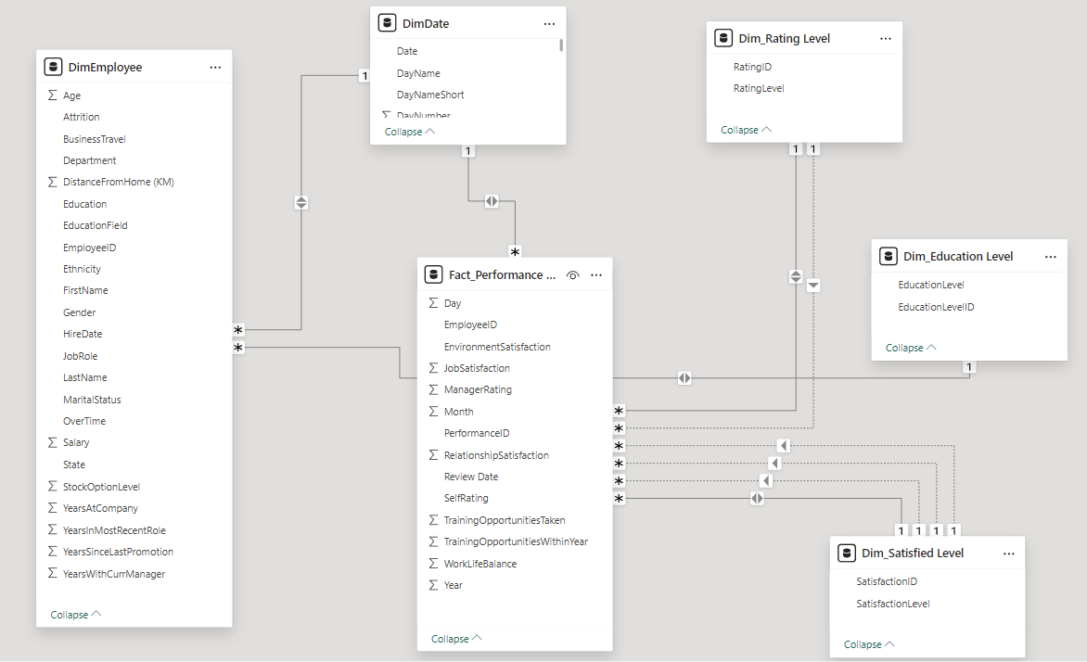

Now that we have loaded data and created our data model, we will now explore the data. The management in particular wants to understand employee attrition.

To explore the data we will first create a separate table which will have all the measures in it, this table will be called _Measures. Following are the measures created in this table.

“Total No of Employees” which counts the number of distinct employees in our dataset. “Active Employees” Which Calculates Employees who are currently in the company.  
“InActive Employees” This is the number of employees who have resigned from the company.   
“% Attrition Rate” Divides InActive Employees by Total No of Employees.

After creating these 4 measure we get an overview of size of the company and rate of attrition.

Total No of Employees = 1470  
Active Employees = 1233  
InActive Employees = 237  
% Attrition Rate = 16.1%

Following is a screenshot of these 4 measures in card visual.

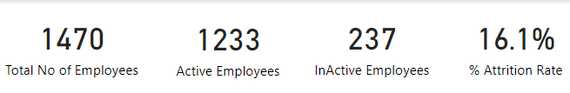

The management wants us to create key metrics which will enable us to benchmark our metrics with Industry average. This will help us in understanding how our employees are performing.

Now we will investigate hiring trend over time. For that I have created a new measure that establishes a relation ship between Dim_Employees table and Dim_Date Table and calculates count of employees hired by date.

TotalEmployeesDate = CALCULATE(DISTINCTCOUNT(DimEmployee[EmployeeID]),USERELATIONSHIP(DimEmployee[HireDate],DimDate[Date]))

We have created a stacked column chart that shows employees hired over the period of time. On the y-axis we have our newly created measure and on x-axis we have date hierarchy from dim_Date table which allows us to drill down from year – quarter – month – Day.

Hiring over time by years: -

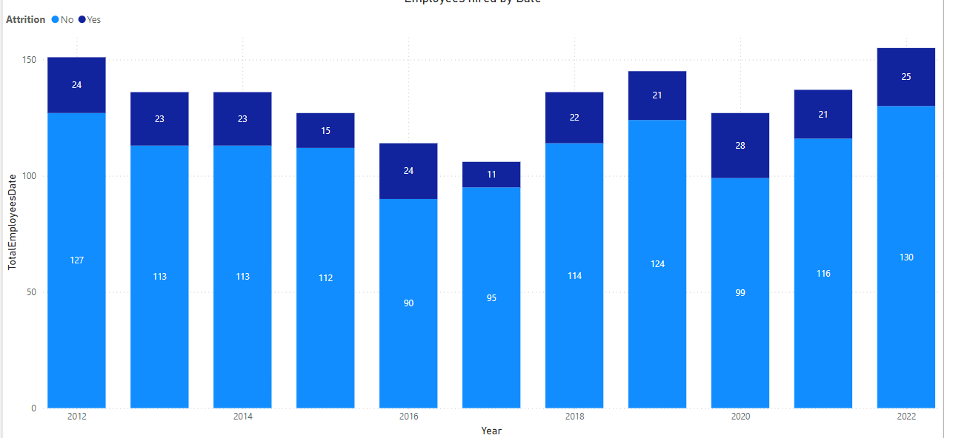

Hiring numbers over time by quarters: -

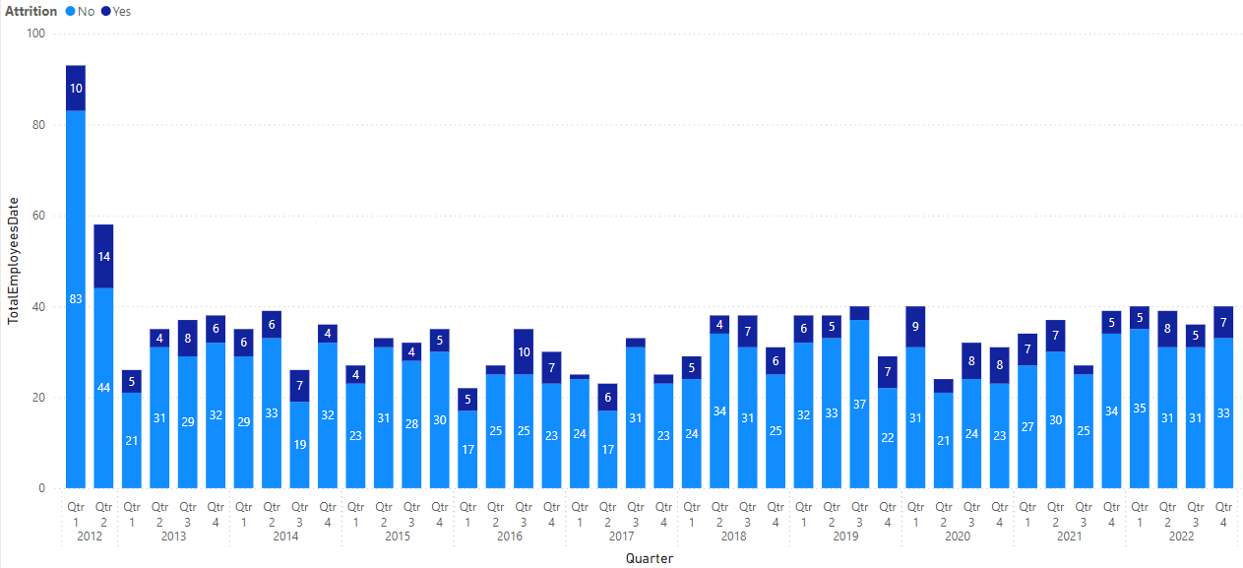

It is interesting to note that in the year 2012 there was no hiring in Q3 & Q4 but high number of hiring in Q1 & Q2. Other than that the hiring number remains relatively stable.

We are working with department managers to understand their requirement and what type of typical roles they need. Knowing this will enable every department to plan for new hiring request for the future.

First we will try to get number of active employees by departments and different job roles.

Below Bar chart shows no of active employees by Department: -

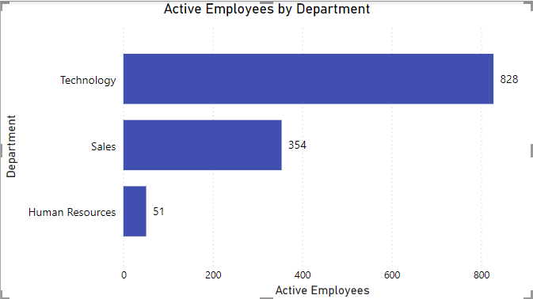

Following tree map gives us an idea of quantity of employees by departments and Job Roles: -

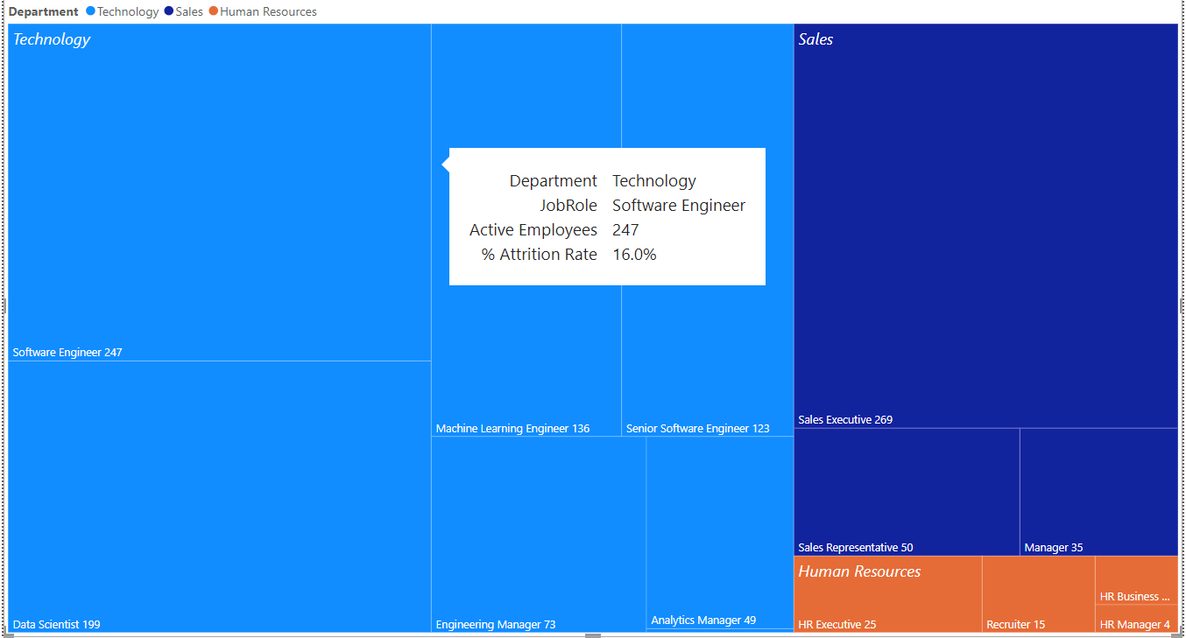

Following Bar Chart shows No of Active employees by Job Roles:-

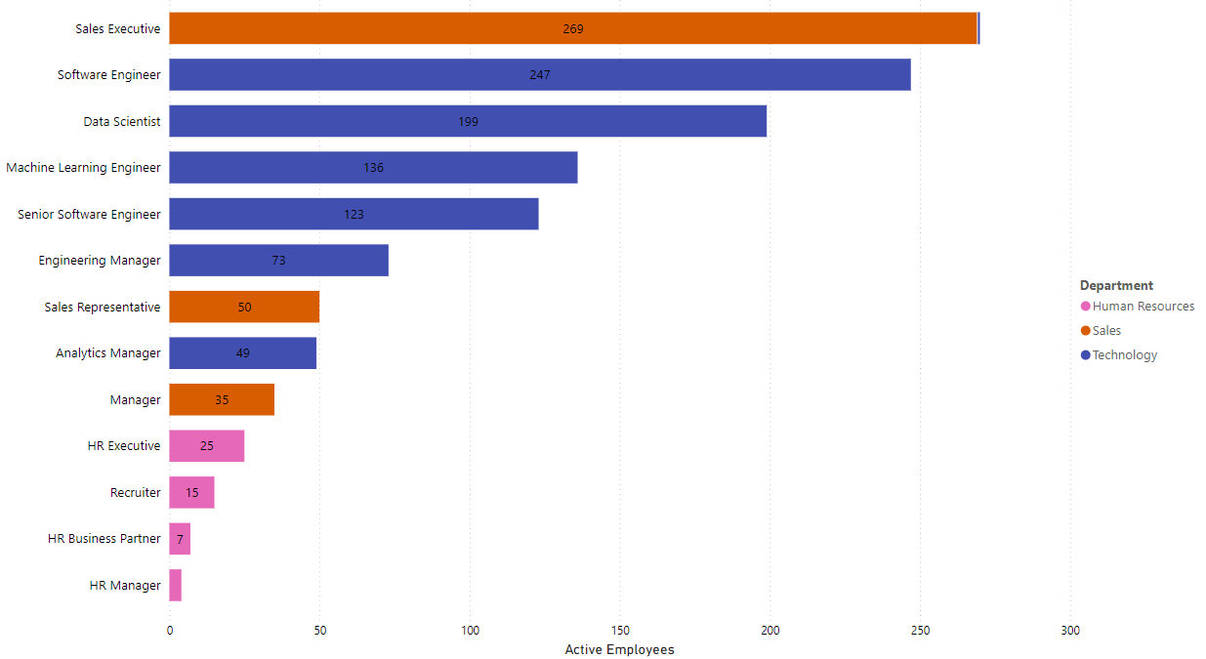

Now we will create a bar chart to see attrition rate by job roles, to see if certain job roles have higher attrition rate.

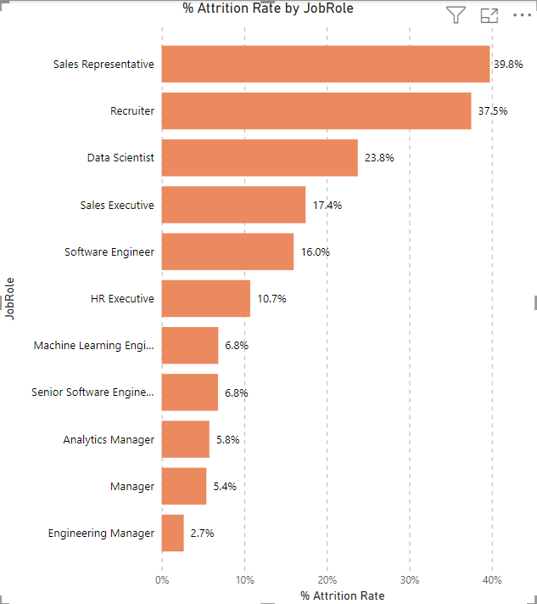

Sales Representative (39.8%) and Recruiter (37.5%) have the highest Attrition Rate.

Next we will explore employee’s demographics starting with age and gender. For age I have created “Age Bins” Columns using conditional column in power query.

Chart below shows number of employees for different age brackets: -

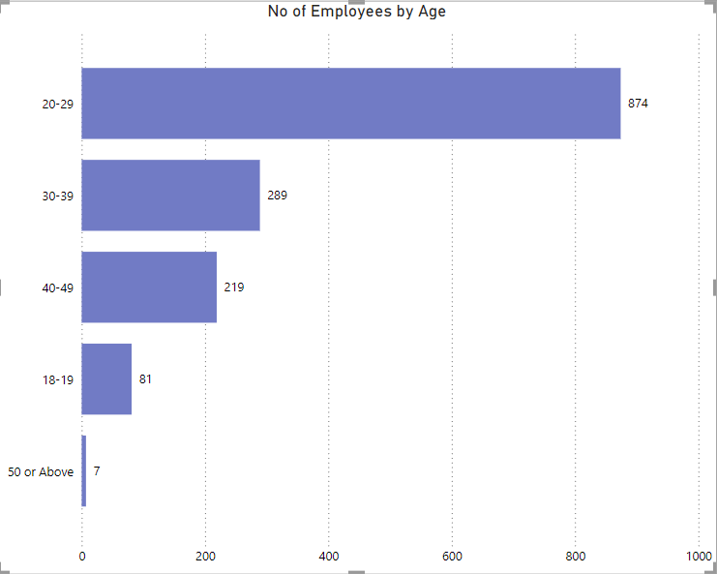

Below chart shows Attrition % by different Age groups: -

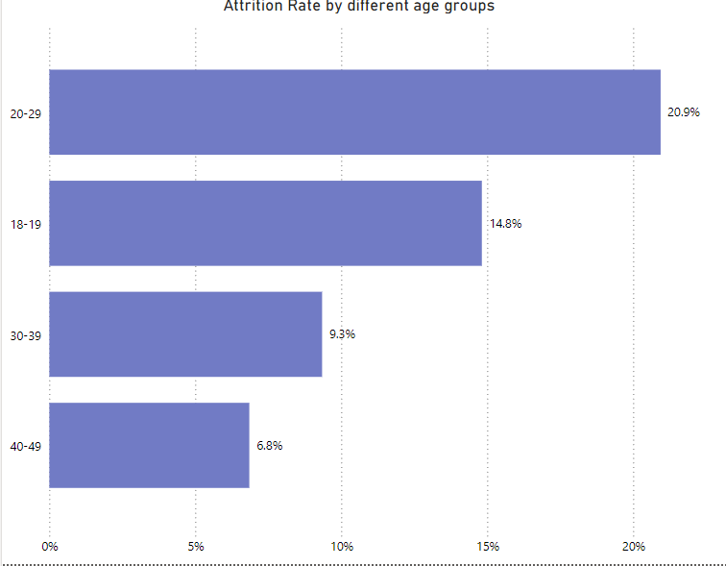

Chart for Attrition Rate by Gender: -

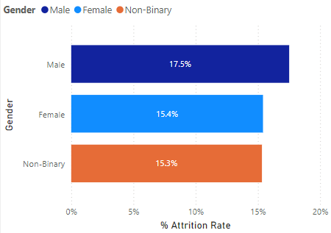

Based on above chart we do not find any significant gender difference in employee attrition.

Next we will be looking at further employee information regarding marital status and ethnicity.

We find that on average singles have slightly higher attrition rate than married employees.

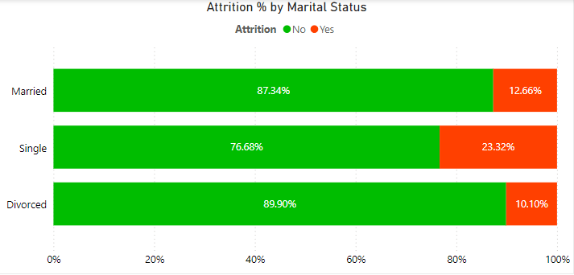

Creating a new measure “Avg Salary” for calculating average salary of employees. Now we will explore average salary for different parameters and weather it has any relation to attrition.

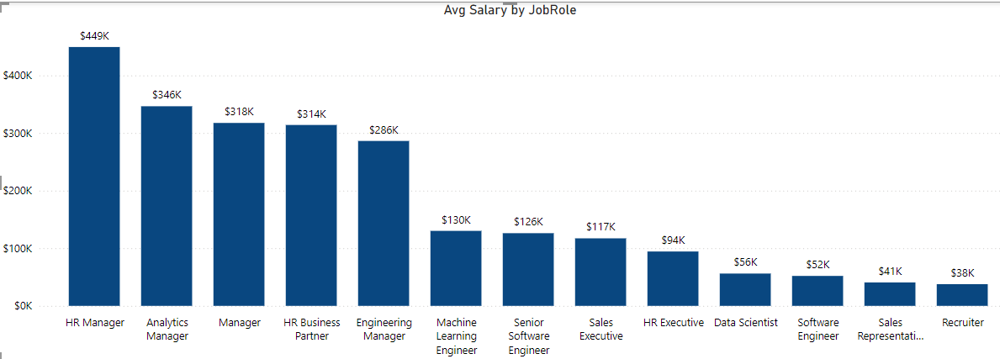

Above chart shows average salary for different job roles.

Now we will create a bar chart to see average salary for different ethnicities.

We do not see any significant difference in average salary for different ethnicities.

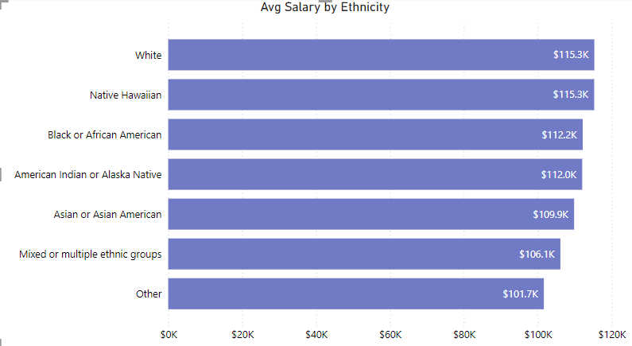

Now that we have explored demographics, we will now create a dashboard where we can track an individual employee’s performance scores based on their yearly performance.

For this purpose, we will create a new measure “LastReviewDate” which shows the latest date when the performance of the employee was reviewed.

Following formula was used: -  
  
LastReviewDate =   
IF(  
    ISBLANK(MAX('Fact_Performance Rating'[Review Date])),  
    "No Review Yet",  
    FORMAT(MAX('Fact_Performance Rating'[Review Date]), "dd/mm/yyyy")  
)

Then we will create a measure for finding the next review date which will be 1 year after last review date or 1 year after the hire date if last review date is blank.

Formula used for Next Review Date: -

NextReviewDate = IF([LastReviewDate]="No Review Yet",MAX(DimEmployee[Hiredate+365]),MAX('Fact_Performance Rating'[Reviewdate+365]))

Following is a screenshot of these 3 dates in a card visual for an employee named “Haley Macilhench”



Now we will create 4 new measure for measuring average rating given by employees over time. And create 4 line charts to see how they change over time. Following line charts show ratings by quarters

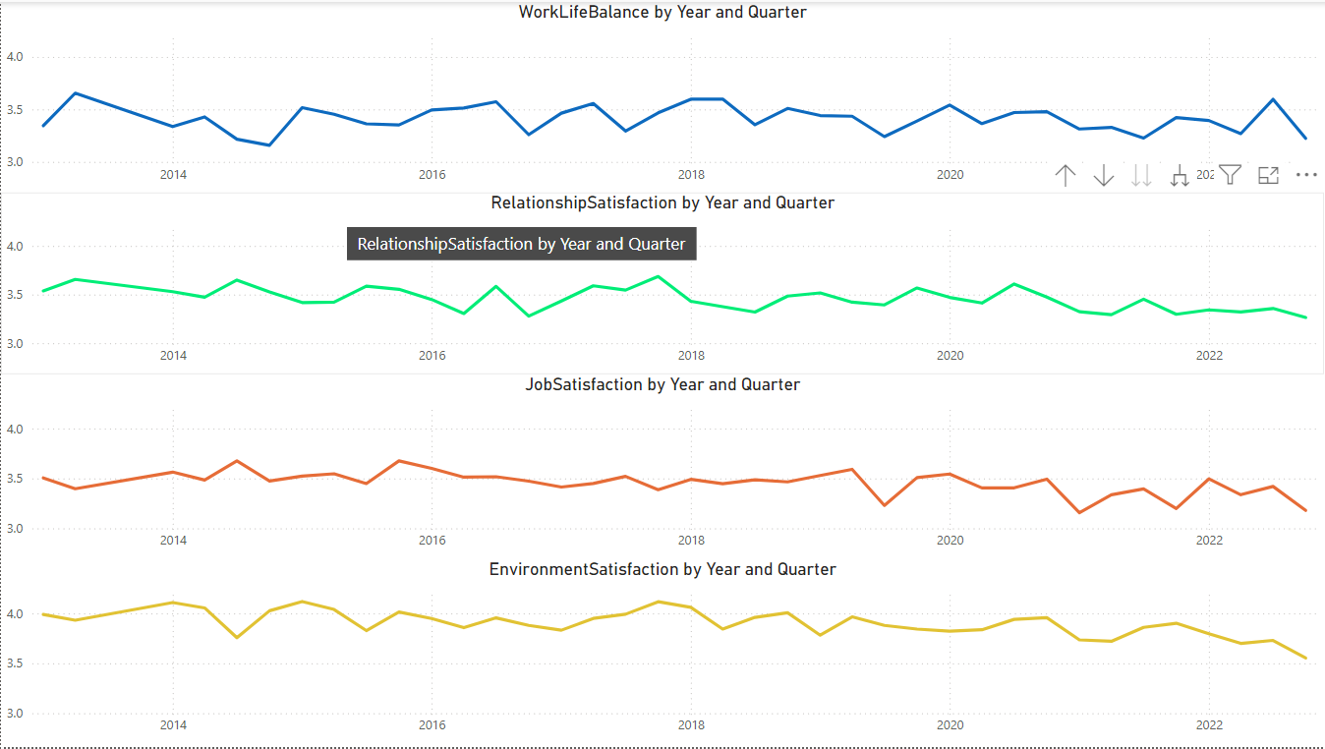

The reviews do not change significantly with time nor do they tell us anything about attrition over time.

Lets investigate other factors which could impact attrition. Next we will create a column chart for attrition rate by “Business Travel Frequency”

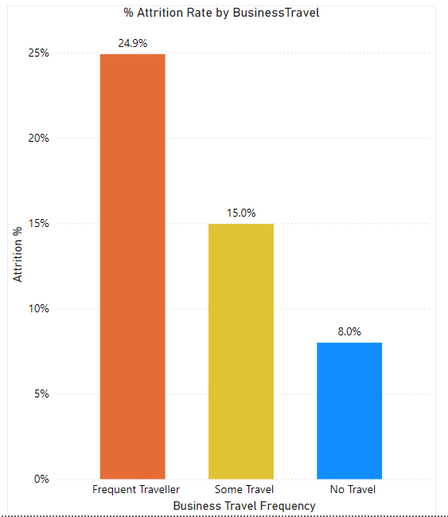

Here we see a clear relationship between more travel frequency and more attrition rate. Our hypothesis is that more travel could be responsible for dissatisfaction with the job.

Now let’s see how over time working requirement impacts attrition rate.

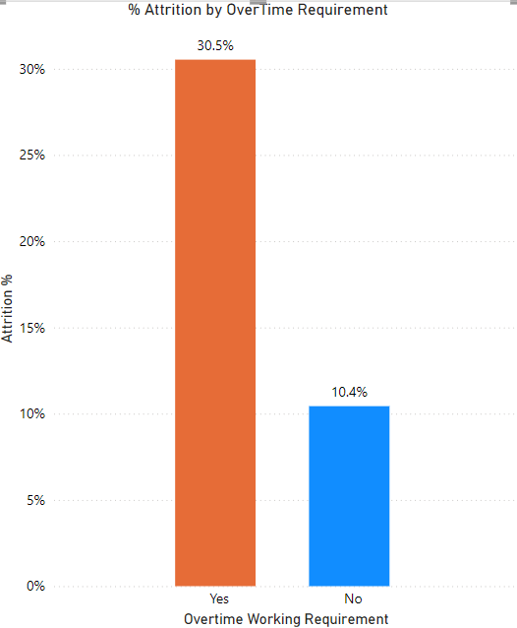

Overtime working employees have much higher attrition rate. This again could be due to stress, work pressure which ultimately leads to dissatisfaction with the job.

Below chart shows Attrition rate by years of work experience at the company.

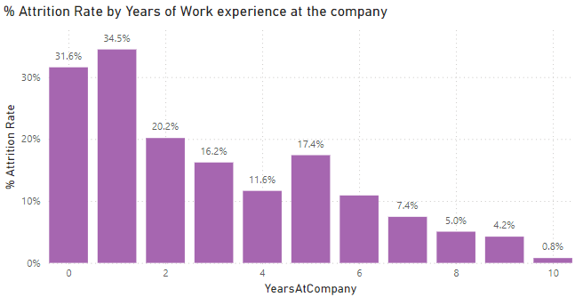

Employees who have spent at least 3 years have less attrition. This could be due to employees developing a sense of belonginess for their job.

Now that we are finished with our analysis. We will create a visually appealing report that management can engage on a regular basis. 5 report pages will be created for regular use. These will be overview, demographics, performance tracker and attrition. We will utilize page navigator to enable easy switching between pages.

**Recommendation for the Top Management: -**

We have found many factors which seems to be positively related to attrition. We will sum them up in points.

1. The top 5 Job Roles which have high attrition are 1) Sales Representative (39.8%) 2) Recruiter (37.5%) 3) Data Scientist (23.8%) 4) Sales Executive (17.5%) 5) Software Engineer (16%)
2. The frequency with which employees are required to Travel for their job seems to have a big impact on attrition rate. The Frequent traveler category of employees have 24.9% of attrition, while some travel category has 15% which is close to average and at last job role which do not have any travel have lowest attrition of 8%.
3. Employees who have overtime work as their job requirement have significantly higher attrition of 30.5% compare to 10.4% of attrition for employees who do not have overtime working as their job requirement.
4. In general employees who have worked for at least 2 years or more than that tend to have lower attrition rate
5. To address the high attrition rates among **Sales Representatives (39.8%)** and **Recruiters (37.5%)** compared to the company's overall attrition rate of 16.1%, it is essential to provide data-driven, actionable recommendations. Below are key insights and strategies I would suggest to stakeholders for reducing attrition for these 2 roles:

**i) Conduct Role-Specific Exit Analysis**

* **Purpose**: Understand the primary drivers of attrition in these roles by analyzing exit interview data or conducting surveys with former employees.
* **Key Focus Areas**:
  + For Sales Representatives: Investigate workload, compensation structure, target pressures, and support from management.
  + For Recruiters: Examine hiring quotas, role expectations, and alignment with career growth opportunities.

**ii) Improve Compensation and Incentives**

* **Sales Representatives**:
  + Review commission structures to ensure they are competitive and achievable.
  + Provide non-monetary incentives such as recognition programs for high performers.
* **Recruiters**:
  + Evaluate compensation in relation to market benchmarks.
  + Offer performance bonuses for achieving hiring goals or innovative recruitment strategies.

**iii) Enhance Training and Development Programs**

* **Sales Representatives**:
  + Introduce advanced sales training to improve skills and reduce stress related to meeting targets.
  + Provide mentorship programs with experienced team members to increase job satisfaction.
* **Recruiters**:
  + Offer training on new hiring technologies and methods to streamline recruitment processes.
  + Create clear career paths and upskilling opportunities to foster long-term growth.

**iv) Focus on Work-Life Balance**

* **Purpose**: High attrition in these roles might be linked to burnout or dissatisfaction with work-life balance.
* **Actions**:
  + Implement flexible working hours or remote work options where feasible.
  + Encourage regular breaks and provide access to wellness programs, including stress management resources.

**v) Conduct Job Role Redesign**

* **Sales Representatives**:
  + Assess the distribution of territories or accounts to ensure fairness and reduce workload imbalances.
* **Recruiters**:
  + Streamline administrative tasks through automation to allow more focus on strategic hiring efforts.

**vi) Improve Leadership and Management Support**

* **Purpose**: Poor management practices often contribute to attrition.
* **Actions**:
  + Train managers to provide constructive feedback and regular support.
  + Ensure open communication channels where employees feel valued and can easily talk about their grievances.

**vii) Promote Internal Mobility**

* **Purpose**: Employees may leave due to a lack of growth opportunities.
* **Actions**:
  + Create pathways for Sales Representatives and Recruiters to transition into other roles within the company, such as managerial or strategic positions.

1. The analysis reveals that **Frequent Travelers** have the highest attrition rate at **24.9%**, significantly above the overall company attrition rate of **16.1%** and much higher than employees with **Some Travel (15%)** or **No Travel (8%)**. This indicates that frequent travel may be a key factor contributing to employee dissatisfaction and turnover. Here’s how you can interpret these findings and suggest actionable solutions to stakeholders:

**Speculation on possible causes: -**

1. **Travel-Related Stress**:  
   Frequent travel may lead to physical and mental exhaustion, disrupting work-life balance and increasing stress levels.
2. **Impact on Personal Life**:  
   Regular travel may interfere with employees' personal lives, leading to dissatisfaction, especially for those with family responsibilities.
3. **Job Role Challenges**:  
   Frequent travelers are likely in roles that require high levels of client interaction, operational oversight, or sales activities. These roles might inherently come with higher pressures or demands.
4. **Cost-Benefit Misalignment**:  
   Employees may feel the compensation or benefits do not adequately compensate for the time and energy spent traveling.
5. **Limited Work Flexibility**:  
   Frequent travelers may have less control over their schedules, leading to frustration compared to peers with fewer travel demands.

**Recommendations for Stakeholders**

**i) Understand the Root Causes of Attrition**

* **Conduct Surveys**: Gather feedback from frequent travellers about their challenges, job satisfaction, and reasons for leaving.
* **Analyze Patterns**: Determine if specific roles, departments, or demographics among frequent travellers are more affected.

**ii) Enhance Support for Frequent Travelers**

* **Travel Perks**: Offer enhanced travel benefits, such as upgraded accommodations, travel allowances, to make travel less stressful.
* **Flexible Scheduling**: Allow travellers to adjust their schedules post-travel to recuperate.

**iii) Evaluate Compensation and Benefits**

* **Incentives for Travel**: Introduce travel-specific bonuses or additional vacation days as compensation for frequent travel demands.
* **Performance-Based Rewards**: Recognize and reward the contributions of frequent travellers through monetary or non-monetary incentives.

**iv) Promote Work-Life Balance**

* **Reduce Travel Frequency**: Reassess the necessity of frequent travel and explore alternatives, such as virtual meetings or delegating travel tasks.
* **Work-from-Home Options**: Offer remote work opportunities for those days where these employees have to do desk work to balance the strain of travel.

**v) Optimize Role Design**

* **Shared Responsibilities**: Distribute travel responsibilities more evenly among team members to reduce the burden on specific individuals.
* **Rotation Policies**: Implement rotation policies to allow employees to alternate between travel-intensive and less travel-intensive roles.

1. The attrition rate for employees with overtime work as a job requirement is **30.5%**, significantly higher than both the overall attrition rate of **16.1%** and the attrition rate for employees without overtime work (**10.4%**). This indicates that overtime is a key factor contributing to employee turnover. Below is a detailed interpretation of possible reasons and actionable recommendations:

**Possible Reasons for Higher Attrition Among Overtime Employees**

**i) Burnout and Exhaustion**

* Excessive overtime can lead to physical and mental fatigue, reducing job satisfaction and overall well-being.
* Employees may feel overburdened, especially if overtime is frequent or excessive.

**ii) Impact on Work-Life Balance & Health**

* Prolonged working hours can lead to stress-related health problems, causing employees to leave for roles with better conditions.
* Overtime work reduces personal and family time, leading to dissatisfaction among employees, especially those with family responsibilities or other commitments.

**iii) Perceived Inequity**

* Employees required to work overtime might feel unfairly treated compared to those without this requirement, especially if the additional effort isn’t adequately rewarded.

**iv) Inadequate Compensation**

* Overtime may not always be compensated at a level that employees feel is worth the additional effort and time spent.

**v) Feeling that Job Role is unsustainable**

* Persistent overtime could signal poor workload management or understaffing, making roles appear unsustainable in the long term.

**Recommendations to Reduce Attrition Among Overtime Employees**

**i) Optimize Workload Distribution**

* **Action**: Re-evaluate workload assignments to ensure equitable distribution among team members.
* **Outcome**: Prevents overloading specific employees and reduces the need for overtime.

**ii) Offer Flexible Scheduling**

* **Action**: Provide options like staggered shifts or flexible hours to accommodate employees' personal commitments.
* **Outcome**: Improves work-life balance and employee satisfaction.

**iii) Enhance Compensation for Overtime**

* **Action**: Offer competitive overtime pay, including bonuses or time-off equivalents (compensatory leave) for hours worked beyond regular schedules.
* **Outcome**: Makes overtime work more appealing and reduces feelings of inequity.

**iv) Hire Additional Staff**

* **Action**: Overtime could be due to lack of sufficient no. of employees so assess whether chronic overtime requirements stem from understaffing and hire additional employees where needed.
* **Outcome**: Alleviates the overtime burden and ensures better workload management.

**v) Implement Technology Solutions**

* **Action**: Use automation tools or software to handle repetitive tasks and reduce manual workloads.
* **Outcome**: Minimizes the need for overtime while maintaining productivity.

**vi) Set Overtime Limits**

* **Action**: Enforce policies limiting the number of overtime hours employees can work per week.
* **Outcome**: Reduces burnout and ensures compliance with labour laws.

**vii) Conduct Employee Surveys**

* **Action**: Collect feedback from overtime employees to understand their challenges and suggestions for improvement.
* **Outcome**: Provides actionable insights tailored to the specific needs of affected employees.

1. Employees with at least **2 years or more** of service have a lower attrition rate, indicating that tenure plays a significant role in employee retention. This trend is common across industries and suggests that employees become more engaged and committed as they settle into their roles and grow within the organization.

**Possible Reasons for Lower Attrition Among Long-Tenured Employees**

1. **Increased Engagement and Loyalty**:  
   Long-tenured employees are likely more familiar with company culture, processes, and colleagues, leading to a stronger sense of belonging and loyalty.
2. **Career Development Opportunities**:  
   Employees who stay longer often benefit from career growth opportunities, promotions, and skill development, which contribute to job satisfaction.
3. **Cost of Transition**:  
   Longer-tenured employees may perceive the cost (personal and professional) of transitioning to another company as higher, reducing their likelihood of leaving.
4. **Cultural Adaptation**:  
   Employees who have been with the company longer are better adjusted to its work culture and expectations, making it easier for them to navigate challenges. Over time, employees build strong professional networks within the company, which contributes to their engagement and satisfaction.

**Recommendations to Leverage This Insight**

To further reduce attrition across all employee segments, it’s essential to apply strategies that help newer employees transition successfully into long-tenured roles. Here’s what the company can do:

**i) Offer Career Development Opportunities**

* **Action**: Provide training programs, mentorship, and clear paths for career advancement to employees starting from their first year.
* **Outcome**: Encourages employees to envision long-term growth within the company.

**ii) Build Engagement Early**

* **Action**: Implement regular check-ins and engagement activities for employees in their first 2 years to address concerns and gather feedback.
* **Outcome**: Identifies and resolves issues before they lead to attrition.

**iii) Promote Peer Support**

* **Action**: Pair new employees with experienced mentors or "buddies" who can guide them during the initial stages.
* **Outcome**: Creates a sense of belonging and support from the start.

**iv) Recognize and Reward Contributions**

* **Action**: Acknowledge employees' milestones and contributions, especially during their first two years, through rewards, promotions, or recognition programs. Increase salary rapidly within first 2.5 years.
* **Outcome**: Boosts morale and incentivizes employees to stay longer.

**v) Encourage Long-Term Retention Through Benefits**

* **Action**: Design retention-focused policies, such as incremental increases in benefits (e.g., vacation days, bonuses) based on tenure milestones.
* **Outcome**: Creates incentives for employees to stay longer.